##### Line Following Robot

By: Susan Ghimire

Introduction: Line tracking Robot is a simple wheel supported Robot which follows the line drawn on the surface which it moves. It tracks the line with the help of infrared sensors (IR) and move according to the data provided by the sensors.

Construction: This Robot is made up of following components:

* + 1. IR sensors (2): These sensors provide the data needed for the Robot to move in the respective path. The IR sensors have a transmitter and a receiver which works simultaneously in order to provide the required info about the path.
    2. Wheels (3) and body: The wheels help in the locomotion of the Robot whereas the body provides the support.
    3. Motor driver (1): Motor driver helps to rotate the motors for the proper movement and turning of the Robot. Data from IR sensors is provided to the motor driver which then rotates the motor so that the Robot follows a line.
    4. Motors (2): Motors are the main components of the Robot. They help in the movement of the Robot. These motors are controlled by their respective drivers.
    5. Battery (1): Battery provides the energy required for the movement of the Robot. Battery is connected to the motor driver and the sensors which further provide the power to the motor and the Robot moves.
    6. Switch (1): it enables or disables the connection of source from motor driver and sensors.

Working: For the proper working of the Robot the battery provides the power to IR and to the motor driver. IR sensors are connected to the motor drivers and the motor drivers to the motors. The Robot is placed in a surface with a white line. When the sensors face the black surface they observe IR radiation and hence the collector can’t sense the Radiation and returns signal to the motor driver and the driver rotates the motor. When the sensor faces the white surface then it returns the signal and the motor driver stops the respective motor. This cause one motor to rotate but other to stop hence the Robot begins to turn in a direction following the line.

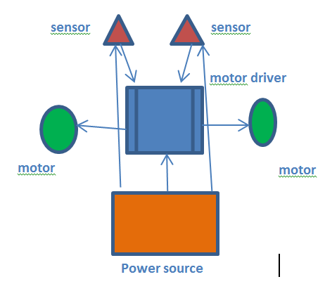 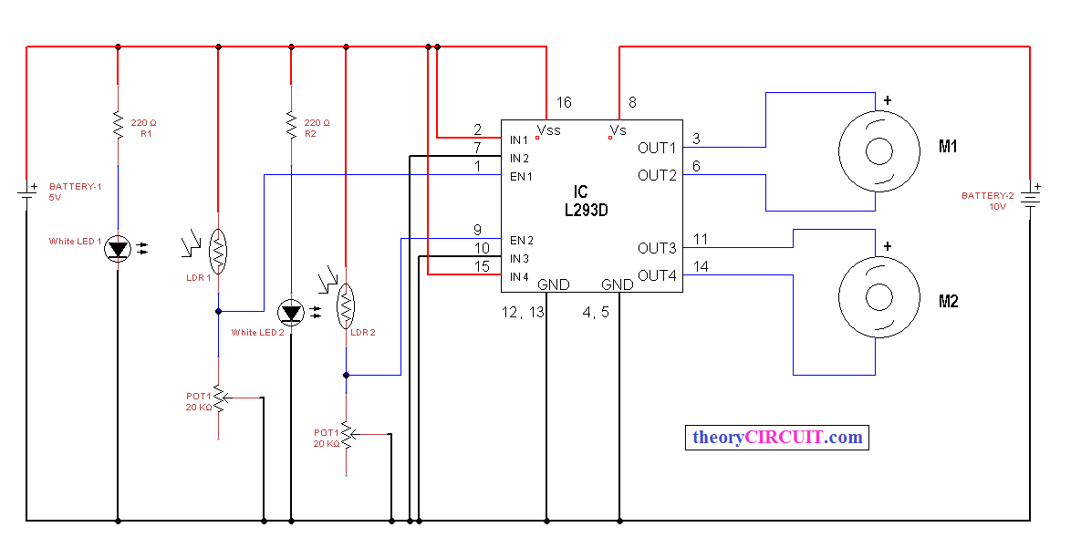 Application and Future Enhancement: As this robot moves only on its path it can be used to make day to day transportation system. Moving materials inside a house or industries will be quite much easier with the help of this robot. As it moves in a fixed path it can be used to do repetitive work in a certain area. In future it can be used to make a fully automated home system where all the transportation works are done by robots. It can be used to transport material from mine which will save a lot of cost and manpower.